Example client survey

Please could you spare five minutes to provide us feedback on the service we offer which will allow us to identify areas that might need improvement. Many thanks in advance for your help.

Name …………………………………………………………
Email …………………………………………………………
Phone …………………………………………………………

Q1) - Overall, how satisfied are you with the service and advice you receive from us?
Please use the rating scale where 0 = not at all satisfied to 10 = extremely satisfied.

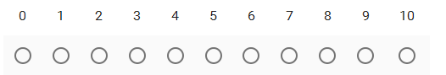

Q2) – Please state the reasons you rated our service this way?

Q3) - How likely are you to recommend us to friends or family?
Please use the rating scale where 0 = not at all likely to recommend to 10 = extremely likely to recommend.
Q4) – Is there anything else we can assist with for you at the moment?

Q5) How do you prefer to receive communications and updates from us
Please tick all that apply.

Email Phone On the website Mail / in post

